Preoperative Exercises
Ball Squeezes
This exercise can be done using a foam ball or rolled up socks.

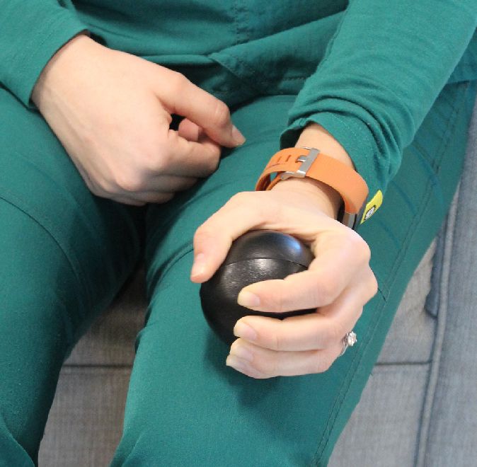
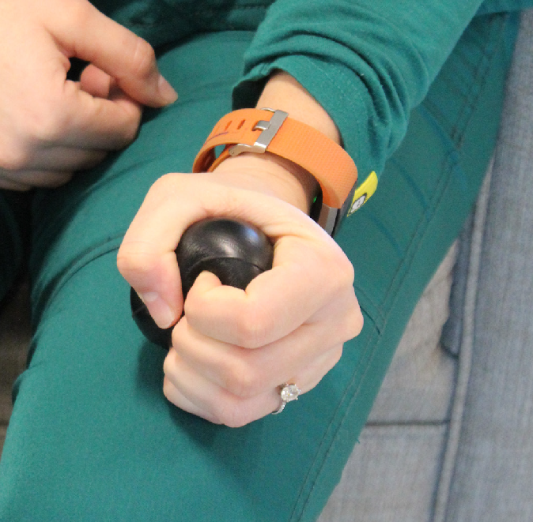
- Place the ball or socks in the hand of your surgical arm.
- Squeeze the ball or socks, hold for 1 second, and then relax.
- Repeat 15-20 times.
- Repeat this exercise 3 times per day.

Elbow Extension/Flexion
This exercise can be done while sitting or standing.

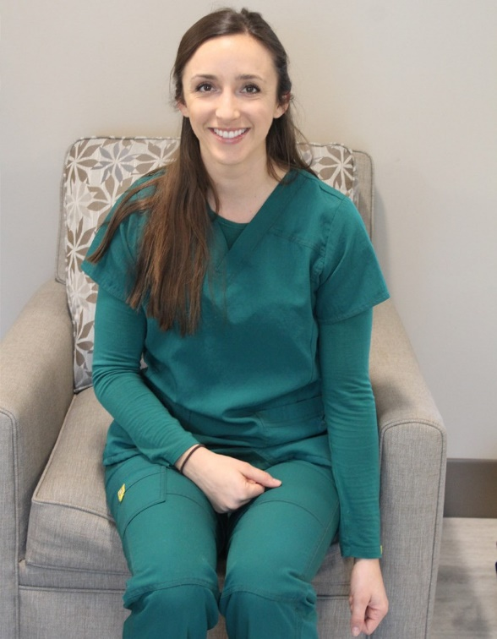

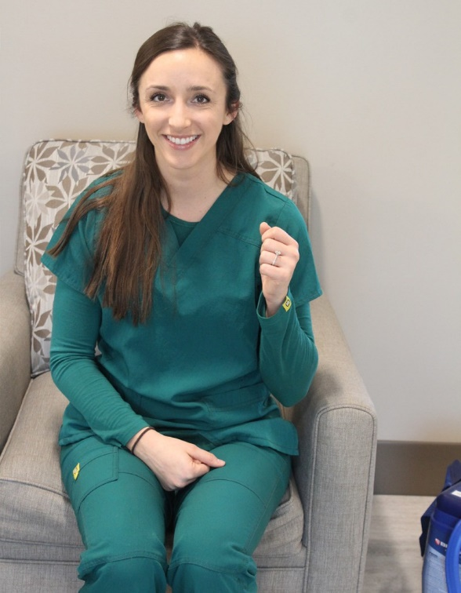

- Start with your arms at your side, hands toward the floor.
- Bend at the elbow of your surgical arm, bringing your hand toward your shoulder.
- Then slowly return to the starting position.
- Rest for 5 seconds.
- Repeat this 10 times.
- Perform this exercise 3 times per day.

Scapular Retraction
This exercise can be done while sitting or standing.

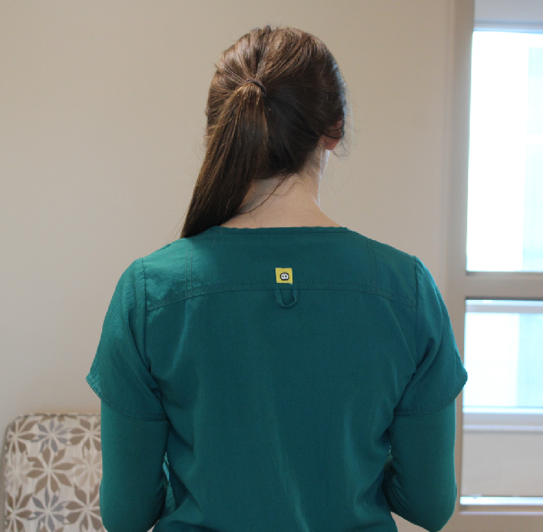
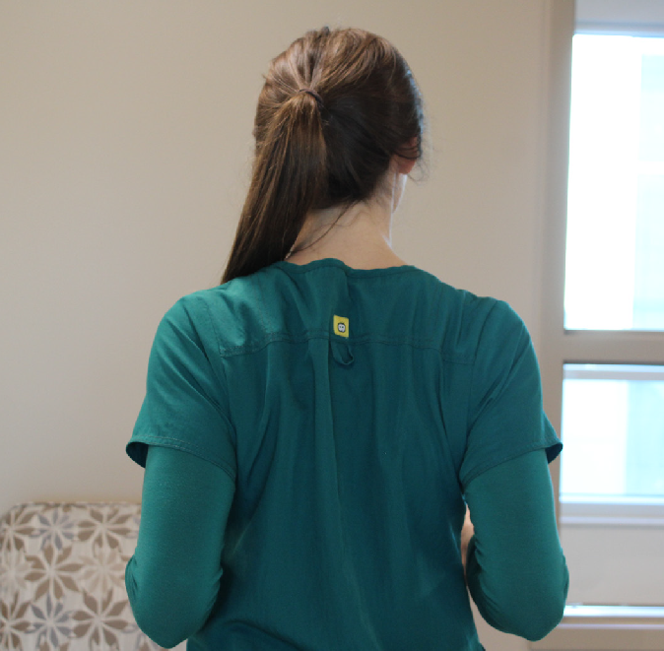
- Bend both elbows to 90 degrees.
- Pull your arms back and pinch your shoulder blades together.
- Hold for 10 seconds, then rest for 5 seconds.
- Repeat this 10 times.
- Perform this exercise 3 times per day.

Shoulder Shrugs
This exercise can be done while sitting or standing.

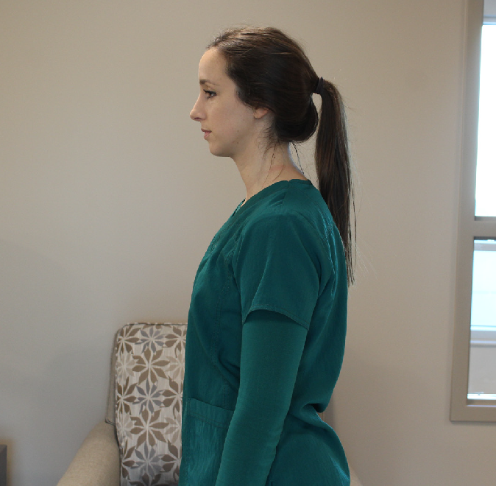
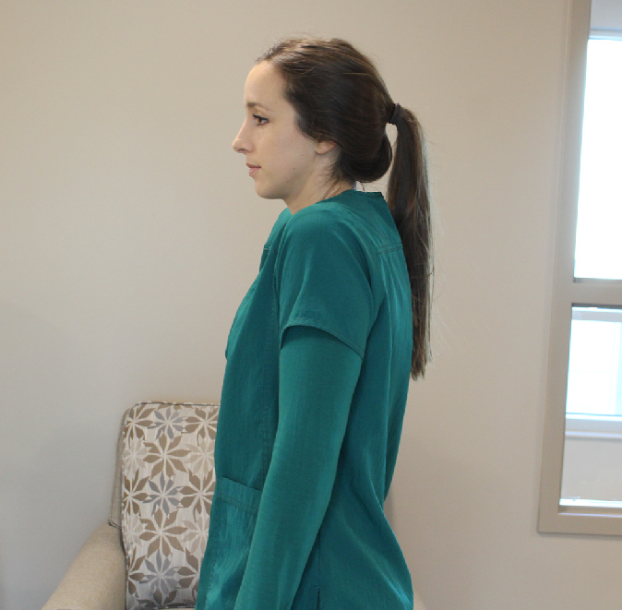
- Start with your arms resting at your side.
- Shrug your shoulders up towards your ears.
- Then press your shoulder blades down.
- Rest for 5 seconds.
- Repeat this 10 times.
- Perform this exercise 3 times per day.
Shoulder Rotation
This exercise can be done while sitting or standing. You will need a cane or a lightweight broom handle.
How to Put the Sling On:

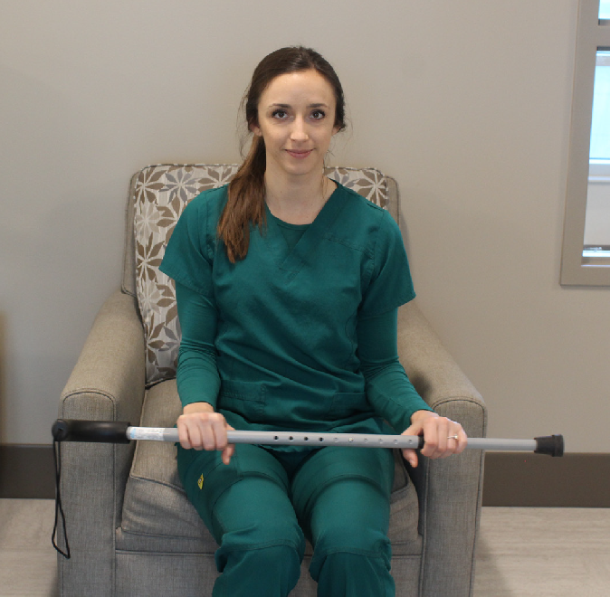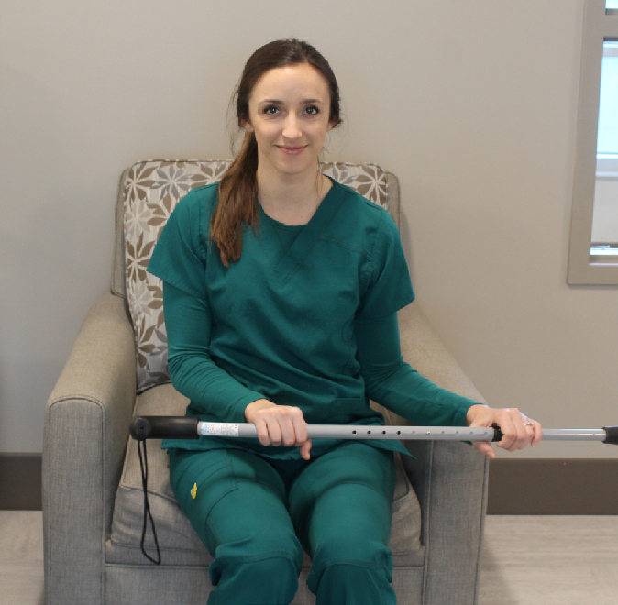

- Begin by holding the cane with both hands, slightly wider than shoulder width apart.
- Turn off the muscles in your surgical arm. You should only be lightly holding onto the cane.
- Using your non-operative arm, begin to gently push the cane toward your surgical arm.
- The elbow of your surgical arm should remain tucked at your side and your forearm should rotate around your elbow.
- You may begin to feel a stretch across the front of your shoulder, but do not push past the point of pain.
- Slowly return to the starting position.
- Repeat 10 times.
- Complete this exercise 3 times per day.

Pendulum Exercise
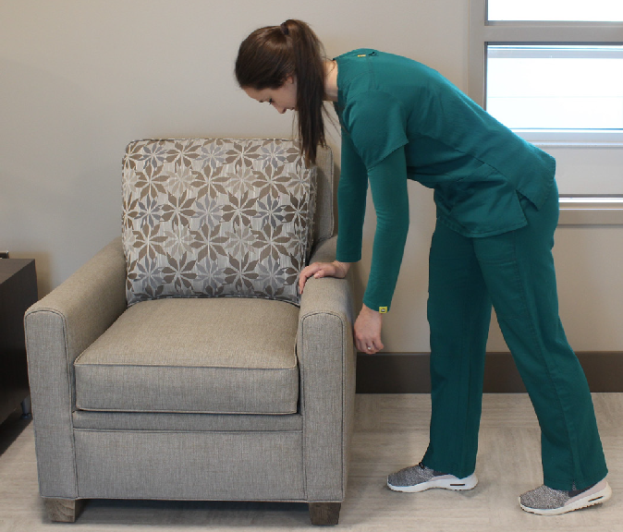
This exercise needs to be done standing at a counter or table
  - Place your non-operative hand/arm on the table for support and bend forward at your waist as shown.
  - Allow your surgical arm to drop forward and come away from your body, allowing the muscles to relax.
  - Place one foot in front of the other and gently shift your weight from one foot to the other.
  - Your surgical arm should gently sway back and forth.
  - Repeat 10 times.
  - Complete this exercise 3 times per day.

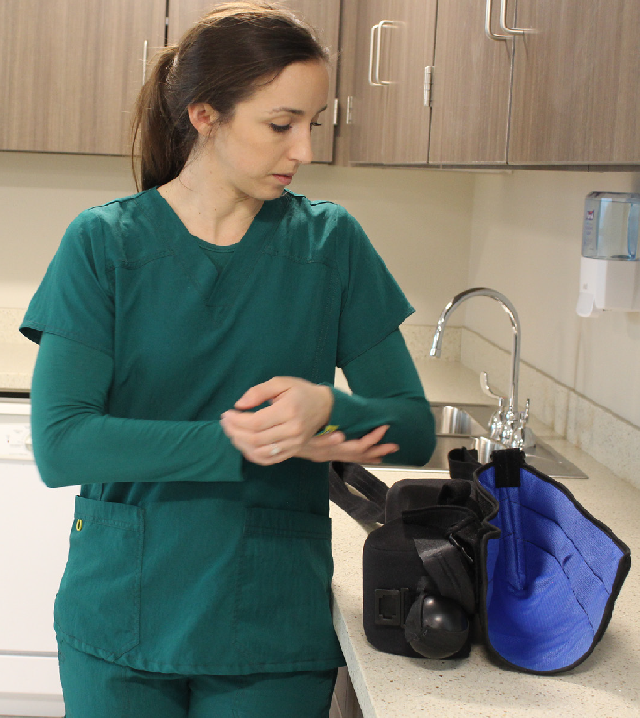
Step 1:
Place your sling on a high table/counter in front of a mirror. Arrange the straps on the counter where you can see them.

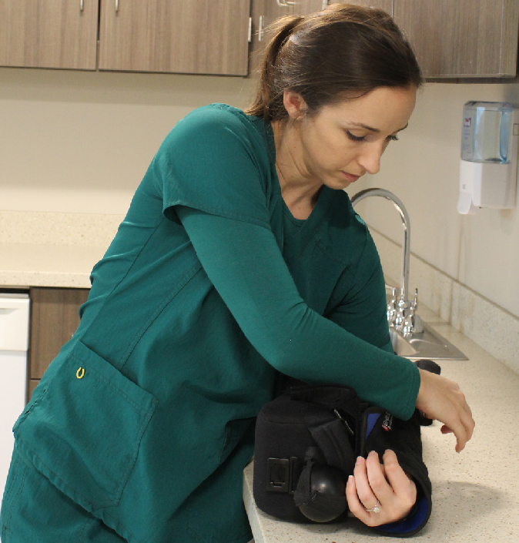
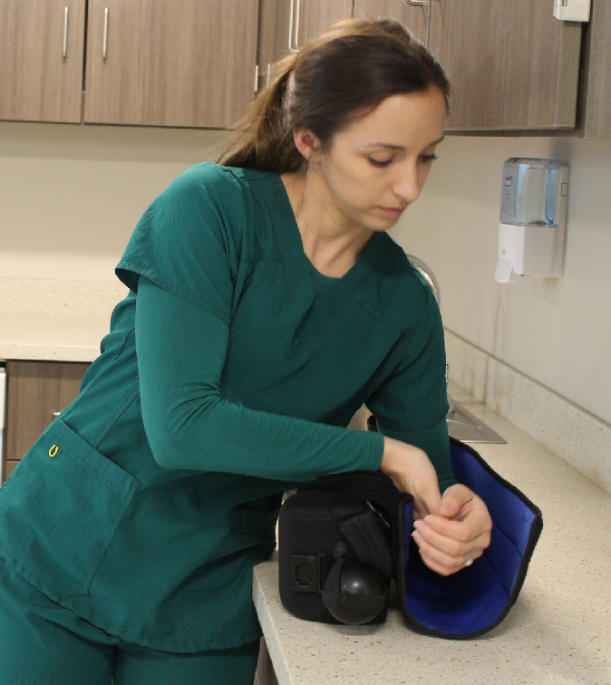

Step 2:
Use your opposite arm to gently lift your elbow and position it snug into the back of the sling. The wedge should be positioned next to your hip.

Step 3
Place the Velcro straps into the correct position. First, the longest strap goes across the top of the sling to keep it closed. Next, the front V shaped strap with the buckle closes the front of the sling. Last, the thumb strap should be placed comfortably around your thumb to keep your hand in place.
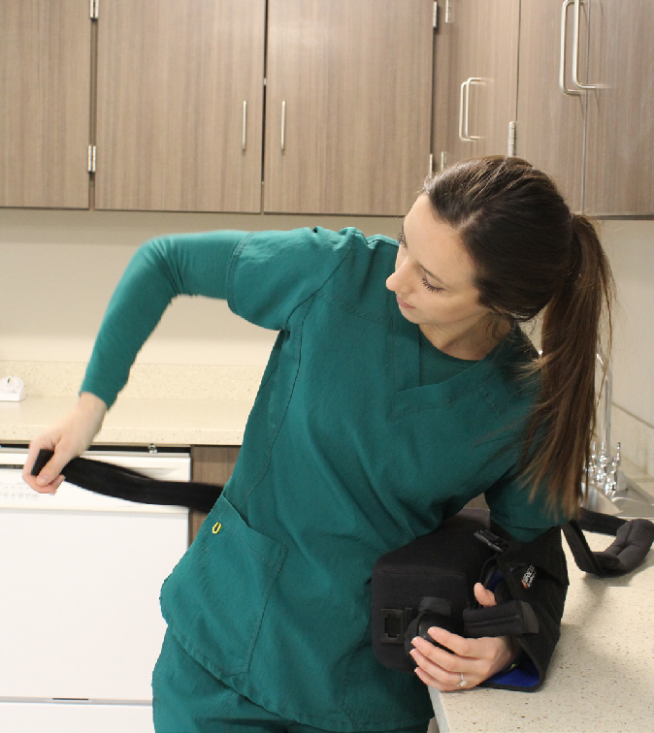
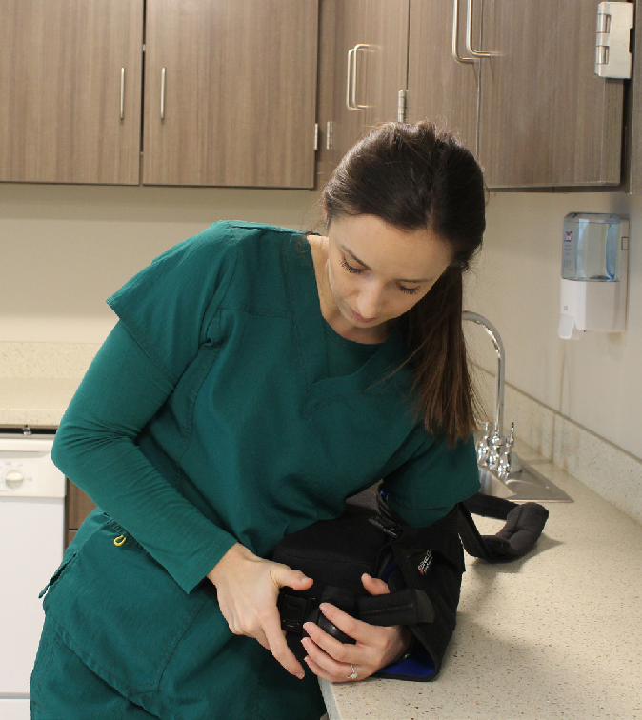

Step 4:
Wrap the waist strap around your hips and fasten it into the buckle in the front of your sling

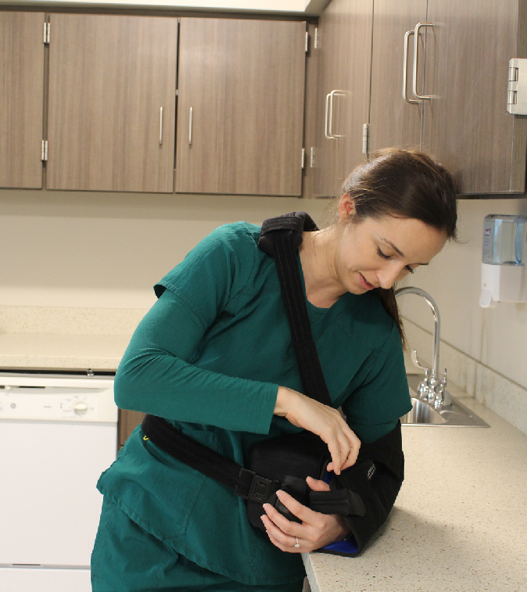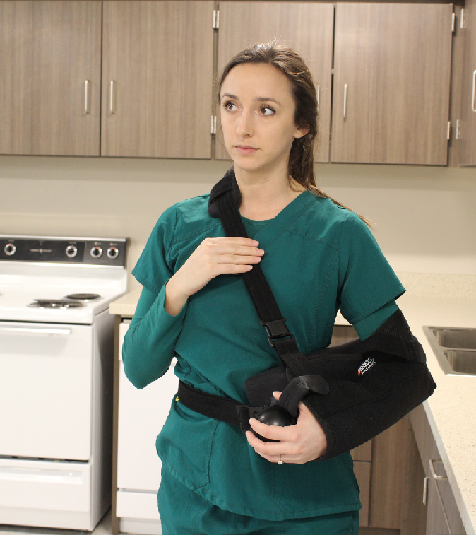


Step 5:
Place the shoulder strap around your neck by attaching the strap into the front buckle.
Step 6:
Ensure there are no twists in either strap and the padded portion of the shoulder strap is positioned comfortably against the side of your neck. Place the ball where you can easily reach it to perform your exercises.

