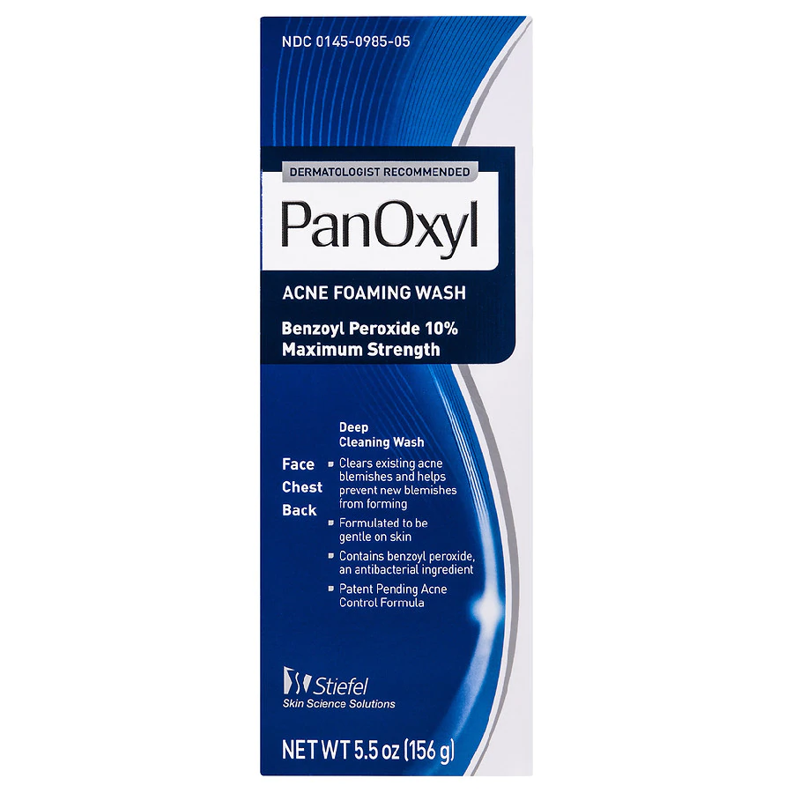

-Buy over the counter in the acne wash aisle

-You will not need a prescription

\*\*Directions:

Wash shoulder everyday ONE week prior to surgery